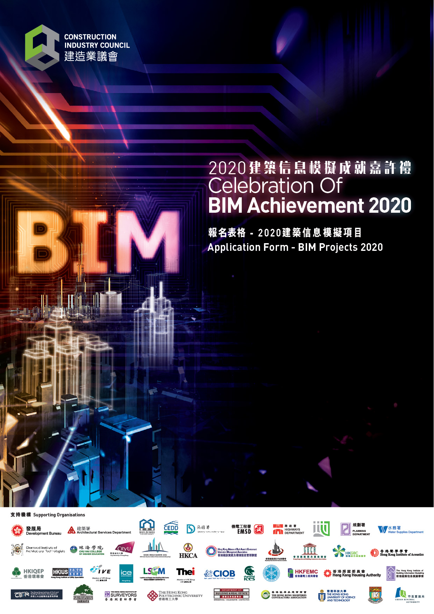

For BIM Projects 2020, we are looking for exemplary projects that have adopted BIM in various project stages for any type of built assets in Hong Kong.

Submission information for Applicants
- Application should be submitted by Email only. Applicants are required to self-create a Google account and store the supplementary information in the Google Drive, and email the shared Google Drive link, completed application form and three project photos (300 dpi, not less than 3MB) by 13 October 2020 to bim@cic.hk .
- The submitted BIM project or research must by implemented in Hong Kong within 1 January 2018 to 31 October 2020.
- Applicants are recommended to list out essential and innovative measures only.
- Applicants should read the relevant requirements set out in the "Eligibility" section of the "Celebration of BIM Achievement 2020".
- Each organisation can submit one project per application and can submit more than one application.

Judging Criteria
Criteria | % | Description
BIM Adoption and Innovation | 60 | - Vision and mission  - BIM Uses across the whole project lifecycle  - Innovative use of BIM  - Certified BIM Personnel
Contribution and Achievement | 40 | - Special achievements and Key Performance Indicators (KPIs) achieved  - Lessons learned and good practices  - BIM-related awards received

Enquiry
Tel: 2100 9000
Email: bim@cic.hk
Website: www.bim.cic.hk/en/events/page/CBA2020

Applicant Information (all fields are mandatory)
Project Name | Click or tap here to enter text.
Name of Project Owner | Click or tap here to enter text.
Project Owner | ☐ Government ☐ Private ☐ Utility Company
 | ☐ Public Client ☐ Statutory Body
 | ☐ Other, please specify: Click or tap here to enter text.
Project Type | ☐ Infrastructure/Civil | ☐ Building | ☐ Sub-structure
 | ☐ RMAA | ☐ AM | ☐ FM
 | ☐ Other, please specify: Click or tap here to enter text.
Project / Contract Period  (For all or any of three main project stages: (1) Planning & Design, Procurement; (2) Construction; (3) Operation & Maintenance) | Project stage(s):
 | ☐ (1) Planning & Design, Procurement
 | ☐ (2) Construction
 | ☐ (3) Operation & Maintenance
From: Click or tap to enter a date.
To: Click or tap to enter a date.
Project Address | Click or tap here to enter text.
Project Website | Click or tap here to enter text.
Name of Applicant’s Organisation / Company | Click or tap here to enter text.
Organisation / Company Address | Click or tap here to enter text.
Contact Person
Title | Choose an item.
Name | Click or tap here to enter text.
Position | Click or tap here to enter text.
Telephone | Click or tap here to enter text.
Email | Click or tap here to enter text.
How do you know about the BIM Achievement 2020? | Choose an item.  ☐ Others, please specify: Click or tap here to enter text.

Project Description (Maximum 200 words* in English, for publicity purpose in future.)
#Three project photos (300 dpi, not less than 3MB) are required to be submitted separately.
Click or tap here to enter text.

* Only 200 words can be shown inside the box.

Part A (60%)
BIM Adoption and Innovation
  - Give one key statement about the project and the project team's vision and mission in use of BIM in the project, and what is so special about this project in BIM adoption and innovation. (for publicity purpose in future)
Click or tap here to enter text.
  - What are the BIM Uses across the whole project lifecycle? Please specify BIM Uses with reference to the DevB’s Technical Circular (Works) No. 9/2019-Table at Annex 1.
Click or tap here to enter text.
  - Are there any innovative uses of BIM apart from those listed in the Table, e.g. use of OpenBIM approach, integrated use with other technologies, etc.?
Click or tap here to enter text.

  - Are there any CIC-certified BIM Personnel or other qualified BIM experts involved in the project?
Click or tap here to enter text.

Part B (40%)
Contribution and Achievement
  - What are the special achievements and KPIs achieved (e.g. but not limited to those in terms of saving in Time and Cost and improved Quality etc.)?
Click or tap here to enter text.
  - What are the lessons learned and good practices to be shared with the industry?
Click or tap here to enter text.

  - Has the project received any BIM-related awards?
Click or tap here to enter text.

Project Team Members to be included for this BIM Achievement (Max. 5 persons)
Title | Choose an item.
Name | Click or tap here to enter text.
Position | Click or tap here to enter text.
Organisation | Click or tap here to enter text.
Roles and Responsibilities | Click or tap here to enter text.
Title | Choose an item.
Name | Click or tap here to enter text.
Position | Click or tap here to enter text.
Organisation | Click or tap here to enter text.
Roles and Responsibilities | Click or tap here to enter text.
Title | Choose an item.
Name | Click or tap here to enter text.
Position | Click or tap here to enter text.
Organisation | Click or tap here to enter text.
Roles and Responsibilities | Click or tap here to enter text.
Title | Choose an item.
Name | Click or tap here to enter text.
Position | Click or tap here to enter text.
Organisation | Click or tap here to enter text.
Roles and Responsibilities | Click or tap here to enter text.
Title | Choose an item.
Name | Click or tap here to enter text.
Position | Click or tap here to enter text.
Organisation | Click or tap here to enter text.
Roles and Responsibilities | Click or tap here to enter text.

Supporting information/documents to the answers in Parts A and B
Please create a google account to store the supporting documents and place the link below:
Insert link: Click or tap here to enter text.
Remarks:
We accept files in the following formats:
- Word/ Excel/ PPT/ PDF and the file size should be limited to 10 pages within 20MB in total
- JPG in 300 dpi and not less than 3MB (max. 10 photos or figures)
- MP4 or MOV with a resolution of HD 1080p (max. 3 videos)

Declaration
I/We declare that:
- I / We have read, observed and acknowledged the entire contents of this Application Form, in particular the “Rules and Conditions” section of this Application Form.
- I / We understand that I am / we are bound and agree to be bound by the terms and conditions of the Celebration as set out throughout this Application Form.
- The information given in this Application Form are correct to the best of my / our knowledge.
- I / We agree that the personal data (as defined in the Personal Data Privacy Ordinance (Cap 486)) provided can be used in accordance with the “Personal Information Collection Statement” of this Application Form.
- To keep you informed of the CIC activities and industry developments which may be of interest, the CIC would like to use your personal data, including your name, phone number and correspondence and email addresses, to update you in relation to training courses, trade testing, registration, events and other aspects of its work and the construction industry. Should you find such use of your personal data not acceptable, please indicate your objection by ticking the box below.
☐ I / We object to the proposed use of my / our personal data in any marketing activities arranged by the CIC and its Secretariat.

 | Click or tap here to enter text.
 | Applicant’s Organisation / Company Name |  | Signature  Please type full name and position:  Click or tap here to enter text.

Annex 1
BIM Uses
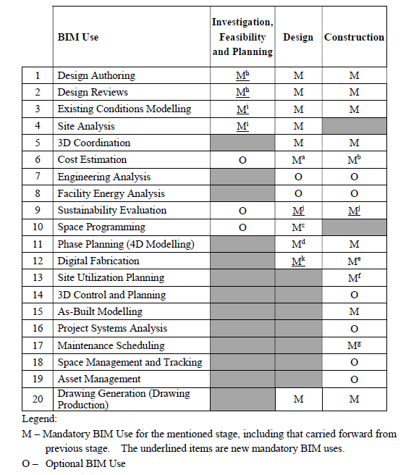

Source: DEVB TC(W) No. 9/2019 https://www.devb.gov.hk/filemanager/technicalcirculars/en/upload/371/1/C-2019-09-01.pdf

Personal Information Collection Statement

The information you provide to the Construction Industry Council (“CIC”), including any personal data as defined in the Personal Data (Privacy) Ordinance (Cap 486), will be used solely for the purposes relating to the activities of the CIC, particularly assessment and publicity purposes relating to the Celebration of BIM Achievement 2020.

To keep you informed of the CIC activities and industry developments which may be of interest, the CIC would like to use your personal data, including your name, phone number and correspondence and email addresses, to update you in relation to training courses, trade testing, registration, events and other aspects of its work and the construction industry.

You are free to decide whether you wish to receive such information. If you choose not to do so, please put a check mark in the box above your signature in the "Declaration" section of this Application Form.

The CIC will not transfer your personal data to any third parties without your prior consent.

It is obligatory for you to supply the CIC with complete information. The CIC may be unable to process and/or consider your application if you do not provide complete information.

You are also entitled to request access to and correction of any errors in your personal data. If you wish to do so please write to the [Data Protection Officer] at 38/F, COS Centre, 56 Tsun Yip Street, Kwun Tong, Kowloon, Hong Kong.

Rules and Conditions
All applicants of the Celebration of BIM Achievement 2020 (Celebration) are subject to these Rules and Conditions (Rules and Conditions) and other rules and conditions that may be imposed by the CIC (the Organiser) and/or the Judging Panel (as defined in the Celebration of BIM Achievement 2020 information leaflet) as deemed necessary. The Rules and Conditions are as follows:
i | The decision of the Judging Panel will be final and absolute on all matters about the process or the interpretations of the Rules and Conditions, voting or any other related issues. The decision of the Judging Panel is binding on all applicants.
ii | No achievement may be granted if no entry is deemed appropriate by the Judging Panel.
iii | Before an achievement is granted, the Organiser reserves the right in their sole and absolute discretion to reject or disqualify any submission without any explanation. Reasons to disqualify a submission include a reasonable belief that these Rules and Conditions have been breached.
iv | The Organiser is empowered and has absolute discretion to grant or withhold an achievement and its decision is final.
v. | If, after an achievement is granted, any information supplied in the respective application is discovered to be fraudulent or untrue, or an awardee is proven to the satisfaction of the Organiser to be associated with a fraudulent or dishonourable act, the Organiser reserves the right, after consulting the Judging Panel, to withdraw the achievement. The Organiser reserves all rights to recover damages or other compensation from the awardee. The awardee will not be entitled to damages or other compensation as a result of the withdrawal of the achievement.
vi | None of the documents and materials submitted with or as part of the application (including all supporting materials for display or demonstration) will be returned to the applicant(s). The Organiser can select to retain or destroy all such documents and materials at its sole discretion.
vii | The applicant(s) authorise the Organiser to use all works submitted by the applicant(s), including the names, photographs or videos of the applicant(s) for promotion, marketing, publicity, display, exhibit or other purposes without any prior consent of the applicant(s). The CIC has the right to publish and exhibit any or all submissions, including the winning submissions, in platforms such as CIC publications, CIC website, BIM Portal, CIC BIM Space and other media platforms etc.
viii | The Organiser shall require the applicants and awardees to participate and present in publicity events, including the taking of photographs and participation in videos, in relation to the Celebration unconditionally and the applicants and awardees shall not unreasonably refuse to participate in the same.
ix | Any opinions, ideas, conclusions or recommendations expressed by the participants of the Celebration does not reflect the views of the Organiser. The Organiser shall not be held liable for any indirect, special, punitive, consequential, lost profits or other damages of any kind in connection with the materials and activities of the Award.
x | All applicants must be the sole and exclusive owner of the copyright in the video. The video submitted should not infringe any rights of any third party. All applicants should only use third party’s music excerpts or film/video segments in the video with the prior written consent of the relevant third party. Applicants must acknowledge any authorised use of music excerpts or film/video segments in the video in accordance with the relevant copyright laws. The Organiser shall not be responsible whether directly or indirectly for any liability arising whatsoever or howsoever from any violation of any copyright laws. Applicants agree and undertake to accept and be responsible for all such liability arising therefrom. For details about the Copyright Ordinance (Chapter 528), please visit https://www.elegislation.gov.hk/hk/cap528
xi | Applicants should declare the video does not:  - infringe or violate, or involve elements that infringe or violate applicable law and regulations, including but not limited to crimes, violence, obscenity, indecency, libel, defamation, privacy invasion, or threatening;  - infringe or violate any intellectual property rights, including but not limited to copyrights, patent, trademarks, trade names, trade secrets or other proprietary rights, held by any third party, regardless whether such rights are known to the applicants;  - contain any confidential information of any third party;  - contain an individual or group of persons, who does not give consent to take such video;  - contain viruses, corrupted files, or other materials that may cause damage to another's computer; or  - advertise or otherwise solicits funds or sales of goods or services.
xii | If the video submitted by the applicant infringes or violates any third party’s rights, including but not limited to intellectual property rights, and/or any legislation, law or regulation, the Organiser shall not be responsible for any consequences.
xiii | When the Organiser suffers from any claim or investigations conducted by any competent authorities, by reason of any right allegedly subsist in the video or infringement of the same, applicants agrees to hold the Organiser harmless and to indemnify the Organiser in full for any direct or indirect loss and damage, economic loss, loss of reputation and/or any consequential loss and damage or otherwise, together with any expenses, costs and further loss and damage suffered and incurred by the Organiser as a result of such claims and investigations.
xiv | The Rules and Conditions are subject to change by the Organiser when necessary. The Organiser reserves the right to amend the Rules and Conditions without prior announcement.

